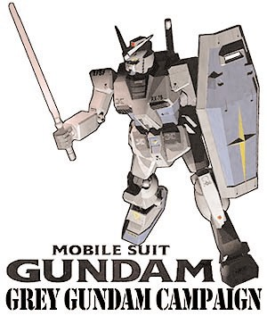

#### A Brief Introduction

###### Welcome to Grey Gundam. This online supplement has been written to allow Pilots to participate in this very first worldwide Mobile Suit Gundam Battle System campaign. In the follow pages you will find a collection of background related to Grey Gundam and new rules - including two special characters and two new Troops types.

**What is a Campaign?**

Wouldn't it be great if your victories gave you an advantage the next time you fought and the men under your command grew and became more skilled with each passing battle? You would know that you skill as a commander was rewarded and the Gods of battle are smiling on you. What if you were fighting for a bigger picture? Where winning the battle meant saving a town from certain destruction, or brought vital time to bring reinforcements to a failing front. Where you might have to fight to the last man for an ideal, which victory means more than just tally of destroyed Mobile suits? This is what a campaign is about.

In a campaign you command a Mobile Suit team as it stomps its way, not only across a battlefield, but also into the pages of history itself. Where each battle counts, and the results of each paves the way for greater victories later on. Where each Pilot and suit gains an individual history and where you come to greet the loss of veterans with groans of dismay. In it's most basic terms a campaign is a series of linked battles.

**Grey Gundam Campaign**

There are many different campaigns to play; the Grey Gundam is what is closed a campaign - with fixed number of battle to fight and a definite ending. Keeping it short helps everyone keep their attention focused on the campaign, because we all have a life and commitments outside our hobby to keep.

For the next eight weeks the MSGBS website will, once a week be publishing a new scenario based on the events of the Federation push into Zeon held North American territory for you to participate in. You can play as many battles as you like based on this new

scenario, and if you are feeling creative you can even play a side scenario based on an unusual occurrence during your game.

Once you have fought you battle and victor is found you can log onto the MSGBS website. Record your results in the Victory Poll to show who is winning the conflict, and even write about your battle in the Grey Gundam Forum Topic. Also once a week the MSGBS website will be publishing a News bulletin, this will bring you up to speed on events within the campaign. With special news items, the latest weather reports rumors of troop movements, mini battle run downs, and brand new rules.

A couple of important points to about the Grey Gundam campaign. This is a Federation Vs Zeon conflict, with a few exceptions the two forces have not been plagued with infighting. If neither side wants to be pigeon holed into leading one type of force, you can swap command of the forces after each battle. Also remember that the MSGBS campaign rules are fully compatible with this campaign.

Now read on Pilots, have fun and good luck…

**Grey Gundam - A Brief Introduction**

*During the closing months of the one year war and Zeon Earth forces still occupy nearly two thirds of Earth. The Federation armed forces for most of the war has been forced to fight with just conventional forces are unable to launch any significant offense against the superior Zeon military, and have been forced to fight pure defensive actions. It's only been through sheer determination, courage, sacrifice and the weight of numbers of the tank squadrons, infantry and air force divisions, plus the timely arrival of the White Base, that the Federal forces have any control over earth's territory at all.*

*With the production facilities of Jabaro Base, the combat data from the Gundam and Project V, the Federation armed forces soon started to see there own Mobile Suits in the form of the GM Type E to combat the Zeon advantage. Over the next two months the Gundam Ground types start to appear and the first time since the beginning of the One-Year war the Federation forces find themselves on a level footing the Zeon Earth force. This is were our story kicks off…*

 

*Although, most of North America has been lost to Zeon, the Federation managed to hold a large part of Canada and now have three Mobile Suit units contesting the border and the territories beyond. The Fourth Federation 'Lougheed' Mobile Suit Battalion and the 30th 'Leg Breaker' Tank Regiment are starting a push to liberate the East coast US territories. The Battalion has been assigned a single RX-78-2 Gundam, under the piloting skills of the Lady Jessica Ide, and are meeting with some initial success.*

*Zeon forces in the area are in a degree of confusion, and have regrouped around the ruined outskirts of Buffalo. Not before losing two Mobile suit companies and several armor and infantry battalions to the Federation offensive. Even fighting in the ruins of Buffalo, the Zeon's have found themselves on the defensive, which has been an unnerving experience for them. It wasn't until the Mobile Suit ace Lance Castle a.k.a. the Blue Max was transferred to them have the Zeon forces been able to stem the Federation offense. Piloting one of the few Gelgoog suits in the Zeon Earth forces, he has been the perfect foil against the power the Gundam, and is only called into action when the Grey RX-78 is sighted.*

*With a stalemate in effect there has been a natural lull in fighting. As both sides are reinforced for the next set of actions - and now you can take part in these battles, deciding the fate of US east coast and your Zeon or Federation forces.*

**The Battle ground**

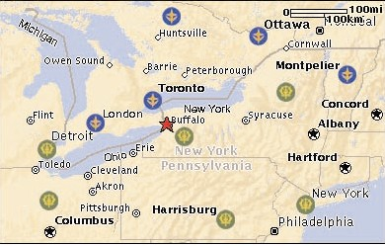

**12th Air Arm**

**Fourth Mobile**

**Soldier Battalion**

**Fourth Mobile**

**Soldier Battalion**

**9th Mobile**

**Rangers**

**5th Mobile Grendiers**

**25th Armor**

**Cavalry**

Zeon Bases

Federation Bases

The Grey Gundam campaign is based on the North American border, the initial fighting mainly took place around ruins of Buffalo City and New York State. The Federation forces have managed to keep a hold of most of Canada and are now pushing back into North America to capture important resources and production facilities.

At this time the Earth's climate has been ravaged by an abortive colony drop and areas of the planet are experiencing dramatic weather changes. North America is no exception although its early fall, the weather is unusually cold and there have been several severe snow storms in the area. A fact that has stopped both sides from being able to deploy their air forces.

Both sides have found themselves fighting all kinds of terrain from urban ruins, verdant forests, rollinghills, mountain ranges and barren wind swept plains. For now, the Zeon forces have rallied themselves and have reformed their defensive lines in the outskirts of Buffalo City. Here in the city limits they are waiting for Federations next attack.

**Federation Forces**

There are several Federation bases in the area; three of these bases are staging areas for the Mobile Suit forces, where elements of Fourth Mobile Soldier 'Lougheed' Battalion are stationed. This reinforced Battalion is lead by Colonel Garren Lougheed, a professional soldier with a keen tactical mind. His Battalion with supporting forces is leading the main thrust into Zeon territory.

The Fourth are being supported by several conventional units, most of which are infantry regiments or Tank companies. The Colonel has the authority to call in support from the 12th Federation Air wing, but with the severe storms in the area this supporting element has spent most of the time grounded.

A recent addition to the Colonel forces is the RX-78-G-3 under the piloting skills of Lady Jessica Ide, and although in theory Lady

Jessica is under the command of the Colonel they have a great deal of freedom as they busy themselves hunting out the Blue Max.

**Zeon North East Forces**

Most of North America is under Zeon control, the areas around the Canadian border have seen the most ferocious fighting of the One Year war and are mainly blasted ruins with very little civilian population left in the area.

The Zeon Earth forces have several reinforced Mobile Suit companies in the area, along with conventional units of infantry and armor. These conventional forces have found themselves based along the border with the Mobile Suit companies in staging areas behind the lines. The overall command of North American sector is General Miko Troist, a ruthless man who obtained his position through political maneuvering than actual ability. The Zeon forces in the area have been suffering from his inspired orders, and he has become increasingly paranoid purging many of his staff officers after accusing them (falsely) of trying to assassinate him.

If it weren't for the appearance of the Zeon ace known as the Blue

Max, the Federation forces would have recaptured the North East Coast weeks ago. Thanks to his sudden appearance on the front, the demoralized Zeon forces have rallied around the Ace. This has added to the General's paranoia and he sees the Blue Max as a threat to his command. Although at the moment the General is content to see if the Ace will get himself killed in combat…

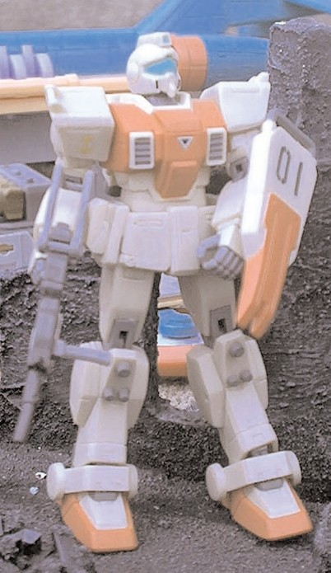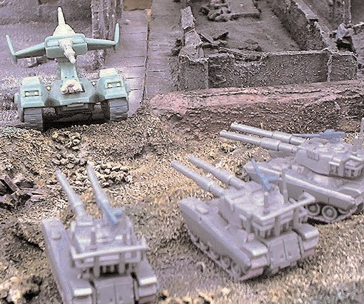

**Game on…**

Okay Commanders the stage is set for the campaign, prepare your suits, ready your men - the fate of the North East coast of America is in your hands…. Good luck Pilots…

# 

OVERVIEW

Zeon and Federation patrols are sweeping the area, trying to locate each others forces. The two patrols have met and are about to engage while reserves move up from behind the lines.

SCENARIO SPECIAL RULES

Reserves - After the second turn units held off the board may enter on there table edge on a 4+.

### SET UP

1. Divide the board into four quarters. Both players roll a dice, the player with the highest score may pick which quarter to deploy in. The other player’s deployment zone is the opposite quarter.
2. The player that scored lowest now deploys one unit in his quarter of the board. His opponent then deploys a unit in his deployment zone. The players take it in turns deploying a unit at a time until both their entire forces are on the table.

Because this is a meeting engagement you can only deploy your troop choices on the board. Heavy Support, Elites, and HQ units must be held in reserve.

1. Roll for who gets first turn. Highest score may choose whether to go first or second.

**Divide the table into 4 quarters and dice**

**for choice of quarter as deployment zone.**

**Armies deploy in opposite quarters**

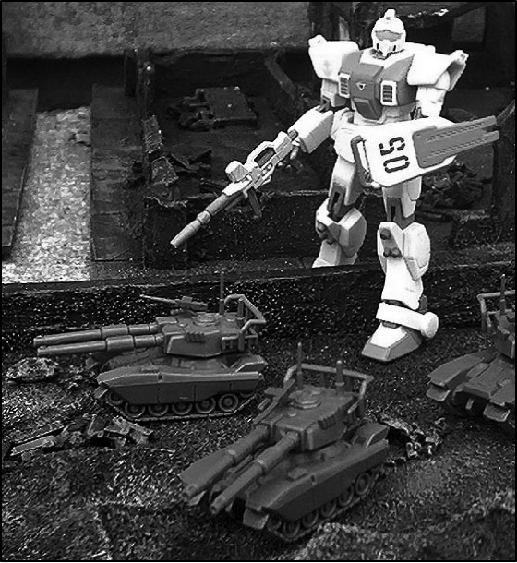

MISSION OBJECTIVE

Both forces are seeking to clear the area of all enemy forces,

securing ground as they go. The player that occupies the most

quarters of the board at the end of the game wins.

To claim a table quarter as occupied there must be no enemy units

of troops, bikes or cavalry over half strength or mobile vehicles in

the area. You must have a mobile vehicle, or at least one unit of

troops, bikes or cavalry with more than half their original number of

models in the area. Note that characters do not count as units and

so may not secure table quarters on their own.

LINE OF RETREAT

Troops which are forced to fall back will do so

towards the nearest board edge of their

deployment zone, using the normal Fall Back

rules.

Reserves

See Special Rules

Game Length

The game lasts for 6 turns.

# 

OVERVIEW

The Federation are meeting heavy resistance from the Zeon forces. The Federation High Command have decided to drop a number of MS teams behind the Zeon lines to take a series of important objectives to and hold until the main Federation force links up with them.

SCENARIO SPECIAL RULES

Air Drop - For each suit choose any point on the battlefield, but not within 18” of an enemy force and roll a scatter dice and 2D6. A ‘hit’ indicates the suit landed on target, an arrow means the suit moved off target and lands the number of inches indicated by the arrow. On a roll of a double 1 the suit suffers a mishap and is immobilised for the rest of the game.

Reserves - After the second turn units held off the board may enter on there table edge on a 4+.

### Set-up

**Zeon forces must be deployed within 12” of objective**

1. Zeon player must place an objective in the center of the board and then deploy only his troopchoices. All other choices must be held off table and can only move in if they make their reserve roll.
2. The Federation player then Air-Drops his forces onto the board in any order he wishes. Plus he may hold units back in reserve to be air dropped if he makes the reserve roll.
3. Roll for who gets first turn. Highest score may choose whether to go first or second.

MISSION OBJECTIVE

The Federation are looking to capture a number of Zeon bases and hold until they are relieved. The player that has the closest unit to the Objective at the end of the game wins.

To claim the Objective there must be no enemy units closer than you and you mobile suit cannot be immobilised.

LINE OF RETREAT

Troops which are forced to fall back will do so towards the nearest board edge of their deployment zone, using the normal Fall Back rules.

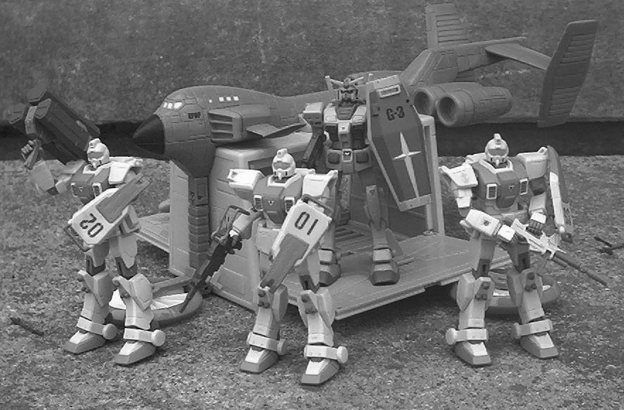

RESERVES

See Special Rules.

GAME LENGTH

The game lasts for seven turns.



### Overview

The Federation second Offensive has gone wrong, many Mobile Suit units have found themselves trapped behind the lines as the relief force was pushed back by strong Zeon resistence. Unable to reinforce these forward units the Federation has issued one command - Breakout!!!

SCENARIO SPECIAL RULES

None

### Set-up

***Attacker’s***

***Deployment Zone***

***2***

***1***

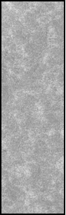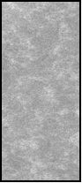

***Defender’s***

***Deployment Zone***

***Defender’s***

***Deployment Zone***



Number the short board edges 1 and 2

1

### SET-UP

***12"***

|  |  |
| --- | --- |
|  | ***6"*** |
| ***Attacker’s Deployment Zone*** | |

***12"***

The Zeon forces must split his force into two parts,

1. one for each short board edge. Each force must

***Attacker’s Escape Route***

***Deployment Zone 1***

***12"***

***Deployment Zone 2***

***Attacker’s Escape Route***

include two whole units, units may not be split between forces. Number these forces 1and 2 to correspond with the short table edges. Note, elite units do not have to be assigned to a table edge, they can be positioned in either force later

***Defender’s***

***Defender’s***

The Zeon Commander deploys all his forces in his

1. deployment zone.

The Federation Commander deploys his units,

1. they may not be positioned with 18” of any enemy

***18"***

***18"***

***6"***

Mobile suit.

***12" 12"***

The Zeon Commander can now deply his Elite units, they can be placed anywhere on the board, but not within

1. 18” of any Federation unit.

Roll a D6: on a 1 the Zeon forces go first, on a 2 or more the Federation gets the firs turn.

## 6

MISSION OBJECTIVE

The Federation Command must get as many of his suits off the board as he can. If he manages to get half of more of his force off the short table edges he wins.

If the Federation Commander does not managed this then the Zeon Commander winsthe closest unit to the Objective at the end of the game wins.

LINE OF RETREAT

Zeon forces that are forced to fall backwill do so towards the closed short board edge. Federation forces which are forced t ofall back will do so towards the centre of the board. All units use the normal Fall back rules and move along the shortest possible route. Once they which the centre of the board they may regroup.

RESERVES

none

GAME LENGTH

The game lasts for six turns.

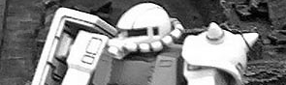

The Federation forces are being driven back on all fronts with the strong Zeon forces snapping at their heels. The Federation army needs to regroup desperately before the Zeon onslaught overruns them. Your Mobile suit team has been selected to stall the Enemy advance for as long as possible as the main Federation force forms a new defensive line.



OVERVIEW

REARGUARD

SCENARIO SPECIAL RULES

Hidden Deployment - Make a Hidden set up marker for each unit in your force (including those held in reserve) - these markers need to be numbered for to correspond to the units in your force. These markers may be placed anywhere on the table within the usual deployment rules. These markers are replaced by the units that start the game on the tabletop after the attacker has deployed.

Any marker that is for a unit that is not deployed on the board may be replaced with a booby trap. The controlling play may choose to detonate it if there is an enemy unit within 6”. Any unit within 6” is automatically hit and takes a single Strength 8 hit to the facing its hit on. Booby traps can only work once.

Reserves - After the third turn units held off the board may enter on there table edge on a 4+.

Random Game Length - After the fourth turn roll a single dice for every turn on a 5+ its the last turn of the game.



### SET-UP

Both players roll a dic. The player that rolls the

|  |  |
| --- | --- |
| ***Attacker’s board edge*** | |
| ***defender’s board edge*** | ***Half the table’s edge*** |

1. highest chooses which long board edge to deploy

from.

The Federation Commander must split his army

1. into two groups, each must contain at least one

Mobile suit or Tank Squadron. Before deploying, the Federation Commander flips a coin or rolls a dice to see which group he will use. The units in the other force are place off table as reserves.

The Federation Commander then deploys his

1. forces using the Hidden set-up rule.

The Zeon Commander splits his forces into two

1. waves. Each wave must contain at least one

Mobile Suit or Tank Squadron and be at least one third of his forces point cost..

The Zeon Commander takes the first turn, moving on from the table edge. Once the first wave is on the board

1. the Federation Commander reveals his hidden set-up markers.

All the forces in the Zeon Commanders second wave arrive at the beginning of turn four, and move on from

1. the attackers board edge. The Federation Commander may roll for reserves after the third turn.

MISSION OBJECTIVE

The Federation Command must stall the attacking Zeon forces for as long as possible. If the Federation Commander has any Mobile suits still able to fire and within 12” of the enemy he wins.

###### 

LINE OF RETREAT

Any suit that is forced to fall back will move towards its own table edge by the shortest possible route, using the normal fallback rules.

GAME LENGTH

Random Game length



BREAKTHROUGH

OVERVIEW

This is it, the turning point of this offensive has been reached the Zeon forces have gathered all their strength and are hurling it against the beleagued, but newly strengthed Federation defensive. Both sides know the course of the war hinges on this moment. For the Zeons they must breakthrough the Federation line, for the outnumbered Federation they must hold at all costs

SCENARIO SPECIAL RULES

Random Game Length, Infiltrators and Rolling Attack

SCENARIO SPECIAL RULES

Rolling Attack - The Attackers troop units that are completely destroyed may be recycled and brought back on the tabletop on the attackers table edge.

Infiltrators - After both sides have set up any unit that can Infiltrate may make a free move just before the battle. Random Game Length - After the fourth turn roll a single dice for every turn on a 5+ its the last turn of the game.



### SET-UP

Both players roll a dic. The player that rolls the

|  |  |
| --- | --- |
| ***Attacker’s board edge*** | |
| ***defender’s 12” deployment zone*** |  |

1. highest chooses which long board edge to deploy

from.

The Zeon Commander deploys along the table edge, the Federation Commander can deploy up to 12” onto the table

Both players roll a dice, the player thats loses teh

1. roll off must deploy one of his units first. The other

player then deploys one of his units. This continues in this order Heavy support, Troop, Elite, HQ until all the units are on the table.

Both players roll a D6 the highest score chooses

1. wether to go first or second.

MISSION OBJECTIVE

To win the battles the Zeon Commander must annihilate the Federation force. He wins the battle if at the end of the game the Federation has no forces left. If the Federation Commander has any forces left at the end of the game he wins the battle

GAME LENGTH

Random Game length

LINE OF RETREAT

Any suit that is forced to fall back will move towards its own table edge by the shortest possible route, using the normal fallback rules.

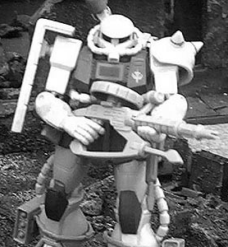

CONVOY



OVERVIEW

The Federation Commander has ordered your team to escort a small convoy of vehicles to the frontline, these vehicles contain the new ground sonar devices able to detect Mobile Suits at a much greater distance. The area is still hostile and Zeon forces have been reported in your sector.

SCENARIO SPECIAL RULES

Hidden Deployment - Make a Hidden set up marker for each unit in your force (including those held in reserve) - these markers need to be numbered for to correspond to the units in your force. These markers may be placed anywhere on the table within the usual deployment rules. These markers are replaced by the units that start the game on the tabletop after the attacker has deployed.

Any marker that is for a unit that is not deployed on the board may be replaced with a booby trap. The controlling play may choose to detonate it if there is an enemy unit within 6”. Any unit within 6” is automatically hit and takes a single Strength 8 hit to the facing its hit on. Booby traps can only work once.

Reserves - After the third turn units held off the board may enter on there table edge on a 4+.

Random Game Length - After the fourth turn roll a single dice for every turn on a 5+ its the last turn of the game.

Convoy - The Convoy is slowing moving affair, only able to go at the pace of the slowest moving vehicle. Each turn roll a D6 on a 1,2 or 3 the convoy moves at 3” on a 4,5 or 6 the convoy moves at 6”.



***6” Defenders Deployment Zone***

### SET-UP

The Federation Commander chooses one of the

1. short table edges as his escape route.

The Zeon Commander rolls a dice for each of his

1. units: on 3+ they may be deployed at the start of

***18”***

***Attacker’s board edge***

***Attackers’s Deployment***

the game. The Zeon Commander may choose to leave units in reserve if he perfers, but at least one unit must be in position for ambush at the beginning of the game. If the Zeon Commander fails to get any of his units at the start of the game he must choose one unit to make the ambush. Any forces which are not ambushing are geld in reserve. The Zeon Commander sets up the ambushing forces using the Hidden Deployment rules. The Hidden Deployment counters may be placed no closer than 18” to the Federations set up zone.

***36”***

***Zone***

***24”***

The Federation Commander places his units and vehicles one at a time. The front unit of the colimn must be

1. at least 36” away from the exit short table edge. Each subsequent unit of vehicle must deploy entirely behind

the previous unit creating a column of march. Note, the Federation Commander’s Convoy consists of D6+2 Hovartrucks at 0 points each (they don’t count towards any troop allotments) If you don’t have enough models to represent the trucks, use turretless Type 61’s or counters.

The Zeon Commander gets the first turn.

## 4

MISSION OBJECTIVE

The Federation Command wins if he gets half his Convoy off the table before the game ends or they are no functioning Zeon units left on the table. The Zeon player wins if he captures two Federation trucks - to capture them he has to be the closest unit to them at the end of the game and unimmobilized. Or their are no functioning Federation units left on the table. Any other result is a draw

###### 

LINE OF RETREAT

Any suit that is forced to fall back will move towards its own table edge by the shortest possible route, using the normal fallback rules.

GAME LENGTH

Random Game length

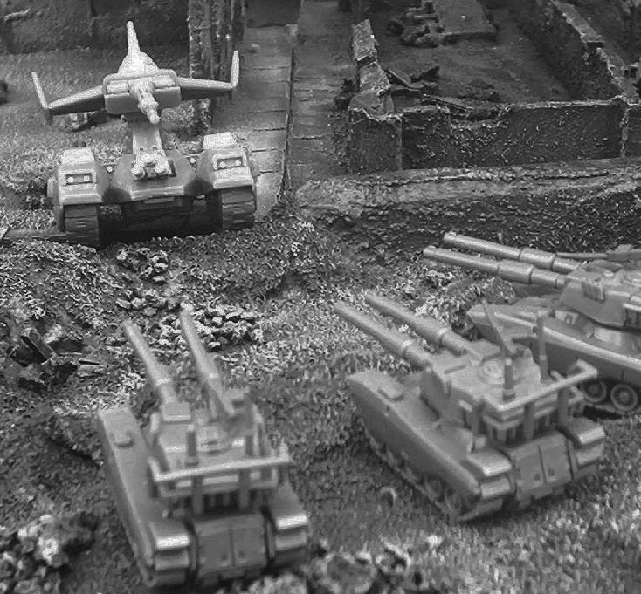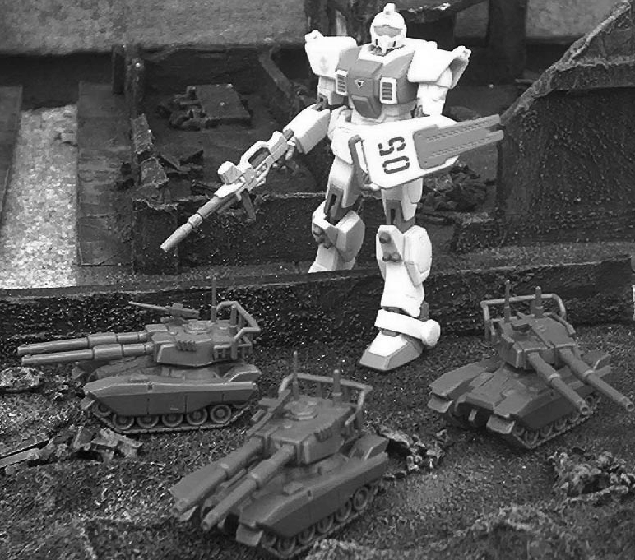

Mobile suits in a combat zone. It carries tools needed for field repairs and all the supplies the team needs for its combat mission.

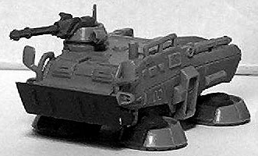

**Hover Truck**

**M WS BS S T I A W LD PV**

Crew Profile 4 3 3 3 3 3 1 1 7 - **Armor Values Front Side Rear PV** Type 74 Tank 6 5 5 50

**Federation Hover Truck**

###### Although its not featured in this scenario in combat capacity I thought it would be fun to introduce one of the support elements of the Mobile Suits teams to the MSGBS.

With the advent of the Minosky particle ground radar is virtually impossible. The old ‘fashioned’ method of spotting and scouting for the enemy has been re-introduced. With radar now as good as useless the Hover truck also has another system to track enemy suits called ground sonar. A skilled operator can track any suit by tremors alone within a mile radius, then relay the information to his team for fire support or attack vectors

T he Federation Hover truck was introduced to support

**Hover Truck Standard equipment & weapon:**

20mm Machine gun (no stats anti-infantry only) and ground sonar.

**Type 74 Army Entry**

*The Type 61 counts as single Troop choice.*

**Type 74 Hover Truck Special Rules**

The Hover truck while next to useless in a duel between Mobile suits is still an essential part of a MS team.

**Ground Sonar** - This special radar allows a skilled operator to track suits by ground tremors alone. The Truck cannot move while using its sonar and it can detect infiltrating targets and ambushers within 36”. Plus relay firing patterns to any Mobile suit within 18” allowing a +1 to hit or a re- roll of the scatter dice.

NIGHT OFFENSIVE

OVERVIEW

It’s total chaos!!! The Zeon forces are falling back in some sectors and counter attacking in others. Your Team has been sent to this sector to bolster the on-going Federation offensive. At nightfall the offensive has begun and your yet to make contact with the enemy. Sonar has reported activity in your area and you have sent your forward units to probe for enemy contact

SCENARIO SPECIAL RULES

Reserves - After the second turn units held off the board may enter on there table edge on a 4+.

Night Fight - It’s night, even with IR viewing the battlefield is a confusing mass of heat sources and muzzle flashes. When firing declare what you are shooting at, then roll 3D6 and times by 2 this is the distance you can see it. If the number rolled is lower than the distance to the target then you cannot see it to shoot at it.



SET-UP

Divide the board into four quarters. Both players

1. roll a dice, the player with the highest score may

pick which quarter to deploy in. The other player’s deployment zone is the opposite quarter.

The player that scored lowest now deploys one

***Armies deploy in opposite quarters***

1. unit in his quarter of the board. His opponent then

deploys a unit in his deployment zone. The players take it in turns deploying a unit at a time until both their entire forces are on the table. No unit can be closer than 18” to each other!!!

Because this is a meeting engagement you can only deploy your troop choices on the board. Heavy Support, Elites, and HQ units must be held in reserve.

Roll for who gets first turn. Highest score may

1. choose whether to go first or second.

***Divide the table into 4 quarters and dice for choice of quarter as deployment zone.***



MISSION OBJECTIVE

The Federation Commander is seeking to clear the area of all enemy forces, securing ground as they go. The Zeon Commander is directing an organised retreat for his forces in this sector, and is trying to secure the ground for conventional forces to retreat through. The player that occupies the most quarters of the board at the end of the game wins.

To claim a table quarter as occupied there must be no functioning (ie immobilised) enemy mobile suits or mobile vehicles in the area. Note that characters do not count as units and so may not secure table quarters on their own.

RESERVES

See Special Rules.

GAME LENGTH

The game lasts for six turns.

LINE OF RETREAT

Troops which are forced to fall back will do so towards the nearest board edge of their deployment zone, using the normal Fall Back rules.

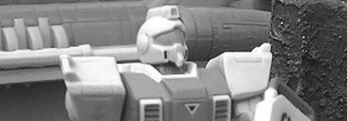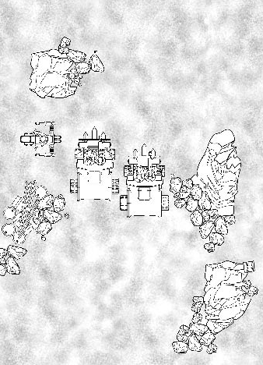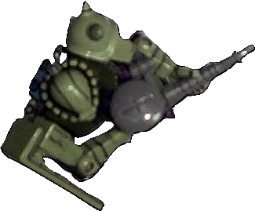

At the start of the turn Zaku II and rocks are moved 6" down the table, whilst the RX-79 run to keep pace. The turned Zaku II may use its normal movement in its turn.

The finally breakthough came last night, after a week of scattered chaotic fighting the Zeon forces seem to be falling back towards there Harrisburg base. Bad weather has hampered their evacutions and the Federation pursuit. Intelligence reports that the members of the Zeon High Command are moving through your sector in

Gallop Land fortress- your orders are too intecept and stop the Gallop.

OVERVIEW

PURSUIT

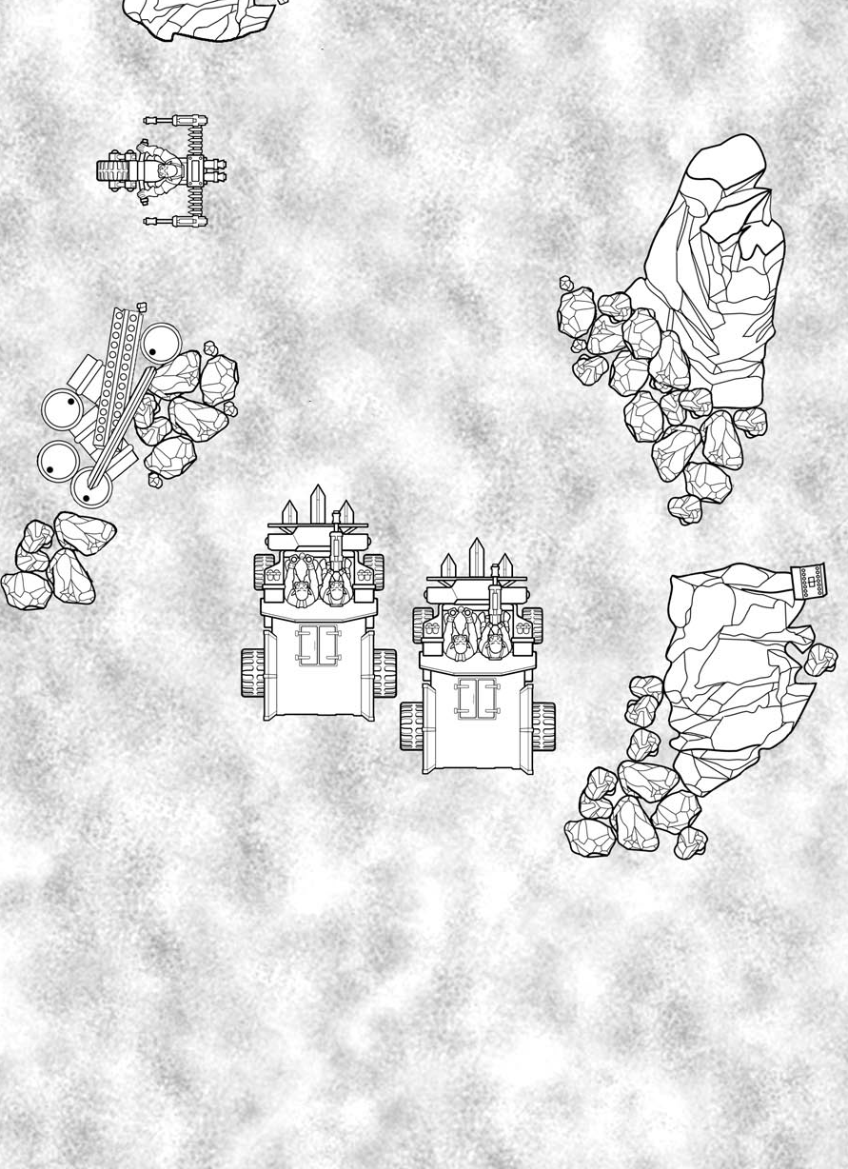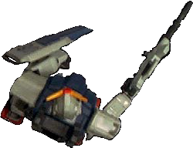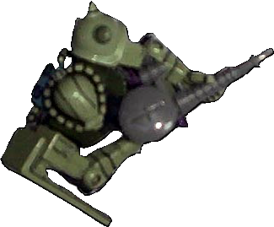

The RX-79 is pacing down the Highway, while the Zaku II has turned to face the Federation suit and is facing more than 45˚ from the direction of the chase.

SCENARIO SPECIAL RULES

Rollin’ Road - Pursuit takes place down the length of the table and you must decide which direction the chase is moving in. In this scenario movement works slightly differently to give the impression of speed. At the start of each of the Federations player’s turns (after the first), there is a special Rollin’ Road phase. During this phase, the players work out the effects of chasing at high speed.

During the Rollin’ Road phase, each player must decide which of their Mobile suits or Vehicles are keeping pace with the pursuit and which are going to drop back. The Rollin’ Road is assumed to be moving backwards at 9" per turn. If the Mobile suit runs to keep pace, then it stays in place. Mobile Suits at more than 45˚ from the direction of the chase will drop back as outlined below, as will any terrain.

Models that are not keeping up with the chase are moved 9" backwards in the Rollin’ Road phase. Models which drop back in this way may move normally in their movement phase without restriction. Mobile suits and vehicles that have run to keep pace may only use their jump packs or thrusters in their movement phase, as the movement from their running has already been used keeping them in place. Don’t forget that the terrain will move as well as the Mobile suits and Vehicles race past rocks and dunes. (watch out for crashes and collisions!).

With the exception of the defenders leaving their attackers behind (see below), any models that leave any table edge except the leading edge cannot return to the fight and are counted as out of action.

**Rollin’ Terrain** - The Pursuit takes place along a highway so not much terrain should be used apart from a few rocks and vehicle wrecks. If a terrain piece moves off the table (see below) both players should roll a D6. The highest scoring player may place the piece of terrain anywhere along the leading table edge, creating a continuous stretch of Highway.

SCENARIO SPECIAL RULES

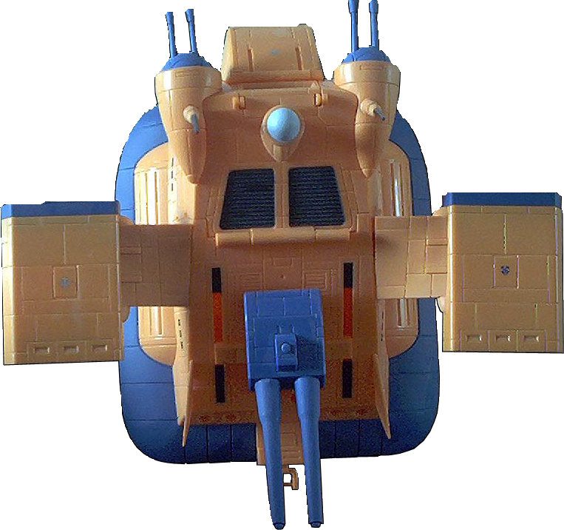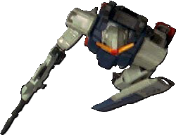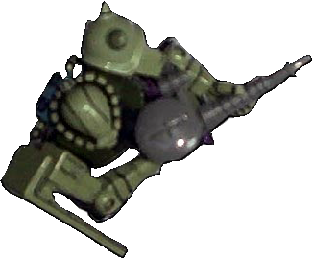

**Boardin’ the Gallop** - The entire scenario is taking place at considerable speed, Mobile Suits cannot board the interior of the Gallop. However Mobile suits may attempt to land on top of the speeding land fortress. In the Rolling road phase the player declares his suit is going to try to board the Gallop. He must declare first without measuring the distance to make the jump. The Suit must be within 8” for a sucessful jump to be made.

If the Mobile suit can make the jump, roll against the Pilots PS at a -2 Modifier to the dice. If the jump is successful move the Mobile Suit on top of the Gallop. If unsuccessful roll a scatter dice and this is the side the suit has fallen off. If they fall off roll against the Pilots PS at a -2 modifier if fails roll on the glancing hit table to see what damage is done to the suit. If passed the suit is assumed to have landed on its feet and may begin to move again in the next rolling road phase.

**Hittin’ the Gallop** - Whilst on board the Gallop the Pilot may attempt to make close-combat attacks against the the Fortress. Roll against the Pilot PS and if he passes he makes one attack (the suit is assumed to be holding onto the Gallop and is limited in its movement), which automatically hits. Apply damage as shown in the Gallop damage charts. You can also fight close combat with another Mobile suit ontop of the Gallop in the same way. The loser is assumed to be pushed off the Gallop unless he makes a successful PS roll at a -2 modifier. If he fails the make a test as described above.

If suits attempt to engage the Gallop as it moves past them, or they get close enough to strike they need a 6 to hit regardless of their weapon skill. This represents the high speed nature of this combat.

**Collisions & Rams** - The Gallop may on purpose or unintentionally hit Mobile Suits or pieces of terrain as it attempts to escape.

Hittin Mobile Suits - This is bad news for the Mobile Suits if they are hit by a speeding Gallop, of course there is a small chance it will do damage to the Gallop as well. If the Gallop moves into contact with a Mobile Suit the Pilot must make an immediate PS roll, if he fails he is hit, if he passes move the suit to the side of the Gallop.

If the suit is hit roll a D6 on a 1,2,3 it takes D3 Glancing hits, on a 4 a Penertrating hit and on a 5 or 6 D3 Penertrating hits. This represents being rolled over by a 100 ton plus war machine!!! Of course the Gallop could take damage too, roll a D6 and on a 6 the suit takes a single strength 8 roll for penetration as normal.

If Terrain is hit the Gallop could take damage from bouncing off rocks, steel girders or even small buildings. Roll a D6 as soon as the Gallop hits the terrain on a 5-6 the Gallop takes a D6 Strength 7 hits on the front, roll for penetration as normal.

The Gallop is attempting to hit the RX-79 (G). The Pilot must make a successful PS (at a -2 modifeir) to avoid the speeding Gallop.

The Pilot makes his test and is moved to one side of the Gallop. If he had failed he would of taken damage as described above

SET-UP

Both players use their Mobile suit team. Only Mobile suit with Jumppacks and vehicles fitted with thrusters can

1 take part in da Chase. The Zeon Defenders are deployed within 36" of one short table edge, all facing in the

direction of the pursuit. The Federation attacker is set up 18" behind the defenders facing in the same direction (if a vehicle or suit is too long to set up this far away, just deploy it on the table edge).

The Federation Attacker gets the first turn and begins with the rolling road phase.

## 2

MISSION OBJECTIVE

The Federation Commander is seeking to stop the Gallop at all costs, to do this they must damage the Gallop until it cannot move. Of course the Zeon escorts may have something to say about this and are attempting to defend the Gallop until it exits the far board edge or there are no more functioning Federation suits on the table.

###### 

RESERVES

None

GAME LENGTH

The game lasts until the Gallop has escaped, destroyed or there are no more functioning Federation suits on the table.

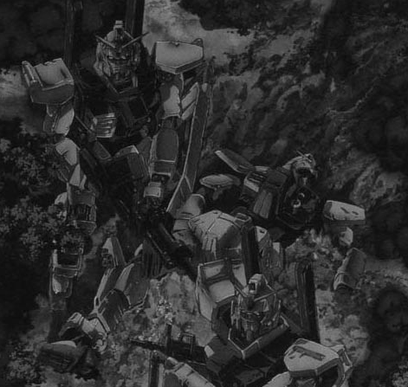

LINE OF RETREAT

Troops which are forced to fall back will do so towards the nearest board edge. Using the normal Fall Back rules.

**Gallop Class**

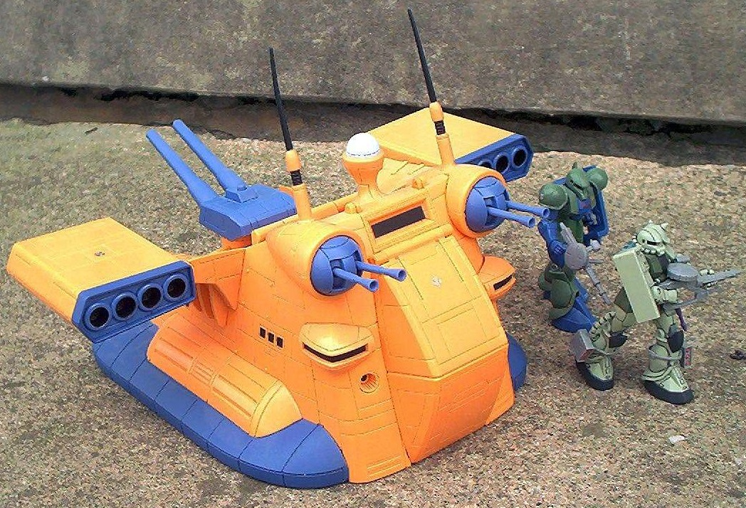

**Unit Type:** land battleship

**Overall Length:** 48 meters **Overall Width:** 44.7 meters **Propulsion:** jet engine x 8

**Mobile Suits Capacity:**

3 Standard Types

**Armament:**

180mm Cannons

120mm Low Reaction Cannon

**Gallop Class - Zeon Land Battleship**

###### The primary land ship used by the Zeon forces, the Gallop is rapid insurgent unit capable of carrying and supporting its own team of Mobile Suits.

It’s smaller than its federation counter-part the Big-Tray and faster, suiting the Zeon blitz style of warfare. During the course of the war these Mega-vehicles have seen action all across the Zeon front. It most famous action was when under the command of Lt Ramba Ral a single Gallop attack unit almost brought down the infamous Federation White Base.

**Gallop Class**

**M WS BS S T W I A PS LD PV**

Crew Profile 4 3 3 3 3 1 3 1 7 8 - **Armor Values Front Side Rear PV** Gallop 14 14 12 350

**Structure Points** - 4

**Transport Capacity** - 3 Mobile Suits or 4 Magella Attack Tanks

##### Move -

###### Cruise (walk) - 6” Flank (run) - 9” Jetboost - 2D6”

**Gallop Class Standard equipment & weapon:**

The Gallop Class comes with this equipment and weapons as standard: Targetor, 2 twin-linked 180mm Cannons and 120mm Low Reaction Cannon

**Gallop Army Entry**

*The Gallop counts as a Heavy Support Choice.. You don’t need to buy any pilots to crew the Gallop as its comes already crewed.*

**Special Rules -**

**War Machine -** The Gallop is a War Machine, it fights in assaults the same as a Vehicle (as described in the WH40K rulebook).

**Jet Boost -** The Gallop is fitted with Jet engines which propel its across the ground. The crew can temporaily boost the performance of the engines. Once per turn the Gallop can choose to move using its boost adding an additional 2D6” to its move.

**Firing -** The Gallop is a War Machine, a huge stable firing platform. It can fire all its weapons with only the targets modifier being applied. However due to the design it has a limited fire arc on its weapons. The front 180mm Cannons have a 45degree fire arc, the rear mounted 120mm Low Reaction cannon has a 60degree fire arc.

**Transport -** The Gallop is capable of Transporting Mobile suits and other Vehicles. The Gallop can only move at cruise speed if its passengers wish to disembark. The Passengers must leave via the front hatch.

**Boardin’ the Gallop** - Mobile suits may attempt to land on top of the speeding land fortress. The Suit must be within 8” for a sucessful jump to be made.

If the Mobile suit can make the jump, roll against the Pilots PS at a

-2 Modifier to the dice. If the jump is successful move the Mobile Suit on top of the Gallop. If unsuccessful roll a scatter dice and this is the side the suit has fallen off. If they fall off roll against the Pilots PS at a -2 modifier if fails roll on the glancing hit table to see what damage is done to the suit. If passed the suit is assumed to have landed on its feet.

**Hittin’ the Gallop** - Whilst on board the Gallop the Pilot may attempt to make close-combat attacks against the the Fortress. Roll against the Pilot PS and if he passes he makes one attack (the suit is assumed to be holding onto the Gallop and is limited in its movement), which automatically hits.Roll for penetration as normal (Gallop top armor is the same as its rear) Apply damage as shown in the Gallop damage charts. You can also fight close combat with another Mobile suit ontop of the Gallop in the same way. The loser is assumed to be pushed off the Gallop unless he makes a successful PS roll at a -2 modifier. If he fails the make a test as described above.

###### If suits attempt to engage the Gallop as it moves past them, or they get close enough to strike they need a 6 to hit regardless of their weapon skill. This represents the high speed nature of this combat.

**Glancing Hit Table - Roll a D6**

1 **Gun Crew Skaken** - May not shoot next turn 2 **Gun Crew Shaken** - May not shoot next turn

1. **Driver Stunned** - May not move next turn
2. **Engines Damaged** – Knock D3” off the vehicles move. (vehicles reduced to 0 movement are immobilised)
3. **Weapon Destroyed** - One weapon is destroyed, this weapon is choosen by the Opponent.
4. **Major Damage -** Lose one structure point and roll again on this table. If reduced to 0 Structure points then roll on the Catastrophic hits table below

**Collisions & Rams** - The Gallop may on purpose or unintentionally hit Mobile Suits or pieces of terrain as it attempts to escape.

Hittin Mobile Suits - This is bad news for the Mobile Suits if they are hit by a speeding Gallop, of course there is a small chance it will do damage to the Gallop as well. If the Gallop moves into contact with a Mobile Suit the Pilot must make an immediate PS roll, if he fails he is hit, if he passes move the suit to the side of the Gallop.

If the suit is hit roll a D6 on a 1,2,3 it takes D3 Glancing hits, on a 4 a Penertrating hit and on a 5 or 6 D3 Penertrating hits. This represents being rolled over by a 100 ton plus war machine!!! Of course the Gallop could take damage too, roll a D6 and on a 6 the suit takes a single strength 8 roll for penetration as normal.



###### If Terrain is hit the Gallop could take damage from bouncing off rocks, steel girders or even small buildings. Roll a D6 as soon as the Gallop hits the terrain on a 5-6 the Gallop takes a D6 Strength 7 hits on the front, roll for penetration as normal.

**Penetrating Hit Table - Roll a D6**

1. **Driver Stunned** - May not move next turn
2. **Engines Damaged** – Knock D3” off the vehicles move. (vehicles reduced to 0 movement are immobilised
3. **Weapon Destroyed** - One weapon is destroyed, this weapon is choosen by the Opponent.
4. **Major Damage -** Lose one structure point and rollon Glancing hits table. If reduced to 0 Structure points then roll on the Catastrophic hits table below
5. **Major Damage -** Lose one structure point and rollon Glancing hits table. If reduced to 0 Structure points then roll on the Catastrophic hits table below
6. **Chain Reaction -** Lose one structure point and roll again on this table. If reduced to 0 Structure points then roll on the Catastrophic hits table below

**Catastrophic Hit Table - Roll a D6**

1. **Damage Control** - The Vehicle Commander must take a LD test on the Vehicles leadership. If the test is successfu then the damage control systems has contained the damage, and 1 Structure Point is ‘repaired’. If failed you must roll again on this table.
2. - 3 **Destroyed -** The Vehicle is wrecked. Mark the destroyed Vehicle with cotton wool or remove it entirely.

4-5 **Explosion** - Models within D6” suffer D3 S7 hits on a D6 roll of 4+. The War Machine is destroyed, as described above.

6 **Huge Explosion -** The War Machine is vapourised in a huge explosion. Roll 1D3 per original Structure points to determine radius of explosion. Models within range suffer D6 S7 hits on a D6 roll of 4+.

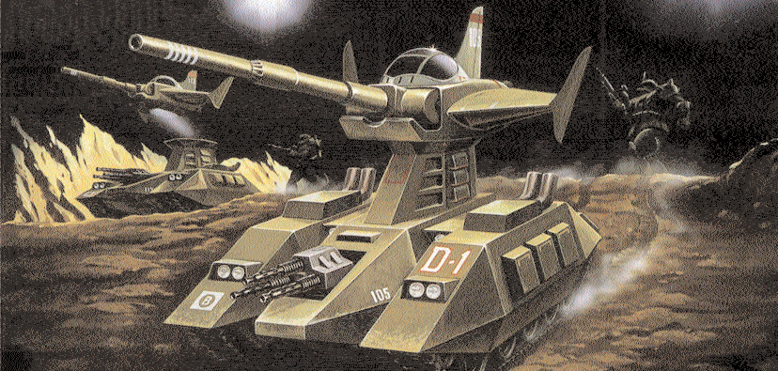

RECOVERY



OVERVIEW

The Gallop was stopped, but before any information or the high-commnad officers could be recovered the vehicle self-detonated. Federation intelligence believe this was just a cover as slow downed footage shows one of the vehicles escape pods ejecting a milli-second before the explosion. You have been sent to this area to recover the escape pod. Intel has also informed you that Zeon teams are also sweeping the area for the pod! Battle is joined as both sides forward elements encounter each other at the crash site...

SCENARIO SPECIAL RULES

Reserves - After the second turn units held off the board may enter on there table edge on a 4+.



### SET-UP

Before choosing table edges or deploying any

|  |
| --- |
| ***Deployment zone 6”*** |
|  |
| ***Deployment zone 6”*** |

1. forces, both commanders place 6 counters

numbered 1 to 6, face down anywhere on the table, (without looking at the numbers on the counters!). The Commanders should take turns placing 3 counters each. Each counter must be no closer than 12” to another counter and no closer than 12” to any board edge.

Determine which on of these counters is the

1. objective by rolling a dice. The counter with that

number on it is the real objective and must be discovered by the Mobile suits during the battle.

Both Commanders roll a dice, the Commander

1. that rolls the highest chooses where he will

deploy. He can must choose which long table edge he can deploy along.

Both Commanders again roll a dice, the lowest then deploys first. He must set up any or all of the units from

1. his Troop allocation in his deployment zone. He does not have to deploy all his Troops, but he must deploy at

least one unit. Any Troops not deployed are in reserve, as is the rest of his forces. The Commander with the highest dice roll then deploys his troops.

Both Commanders again roll a dice, the highest score may choose wheter to take the first or second turn.

## 5

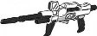

RESERVES

See Special Rules.

GAME LENGTH

The game lasts for six turns

LINE OF RETREAT

Units which are forced to fall back will do so towards the nearest board edge of their deployment zone, using the normal Fall Back rules.

MISSION OBJECTIVE

The Commander that is in possession of the objective at the end of the games wins. If no one has the objective at the end of the game then it is a draw.

To reveal a counter the Commander must move a Mobile Suit into contact with it and the halt the model’s movement. Turn the counter face up and see which number it has on it. If the counter is the one with the number rolled at the start of the game the model has located the objective, and it is now in that model’s possession. If the counter is any other number discard it and keep hunting.

If the model carrying the objective is destroyed, or immobilised, or has to Fall Back then the counter is dropped and remains on the board. It may be picked up by any model that moves into contact with it

The model can pass the objective to another by moving into base to base contact. Neither model may move after they come into contact until the next turn, and the objective can only be handed off once per turn.



OVERVIEW

LAST DANCE

The Zeon MS forces made off with the escape pod and Federation Intel is certain it contained General Miko Troist

- the overall Commander of the North East. Meanwhile Zeon resistance has effectively collapsed all along the North East and with only the immeditate area around their Harrisburg base remains in their hands. Right now Federation forces are fighting a savage battle to take the base.

Your Team has been selected for a very special mission, Federation Intelligence has learned about a total annihilation device that is in the hands of General Troist. The General is an extremely paraniod man and Intell are certain he will use the device should the bases defenses fall, irradiating the entire North East for centuries to come!!!. Your mission is to breakthrough the bases rearline and into the base complex itself, Intel has places the General in the bases central command bunker you must stop him at any cost.

SCENARIO SPECIAL RULES

Deep Strike - After the second turn units held off the board may enter on there table edge on a 4+.

Hidden Deployment - Make a Hidden set up marker for each unit in your force (including those held in reserve) - these markers need to be numbered for to correspond to the units in your force. These markers may be placed anywhere on the table within the usual deployment rules. These markers are replaced by the units that start the game on the tabletop after the attacker has deployed.

Any marker that is for a unit that is not deployed on the board may be replaced with a booby trap. The controlling play may choose to detonate it if there is an enemy unit within 6”. Any unit within 6” is automatically hit and takes a single Strength 8 hit to the facing its hit on. Booby traps can only work once.



### SET-UP

Roll randomly for which short table edge will be

|  |  |  |  |
| --- | --- | --- | --- |
| ***Base Perimeter 6”*** | ***No Mans Land 18”*** | ***Defenders Patrol Zone 12”*** | ***Attackers Starting Edge*** |

1. the attackers starting point. Then divide the board

as shown on the Map.

In this battle the Zeon Commander only uses half

1. his forces available to him, ie. If the Federation

Team is 1000 points, the Zeon team can only field 500 points. The Zeon Commander must at least place one unit of his available force in his patrol Zone. Any Zeon units not placed in the patrol zone are set up using Hidden Deployment and set up in No Man’s Land.

The Federation Commander then deploys his

1. entire force along his Starting edge. He may hold

units back using the Deep Strike rules if he wishes.

The Federation Commander gets the first turn.

## 4



GAME LENGTH

The game lasts for six turns

LINE OF RETREAT

Units which are forced to fall back will do so towards the nearest board edge of their deployment zone, using the normal Fall Back rules.

MISSION OBJECTIVE

The Federation Commander must smash through the Zeon Commanders lines. For every Fed unit that leaves via the far base perimeter line the Federation commander gets 300 victory points.

The Zeon Defender must hold his line and stall the Federation attack. The Zeon Commander gets +150 points for each enemy vehicle or suit that is not in the Base Perimeter line at the end of the game.

The Winner is the Commander with the most Victory points. After playing this scenario to its completion move onto the second part of this scenario.



LAST DANCE**pt2**

OVERVIEW

You’ve broken through to the base, you team is strung out behind you but your objective is in sight. General Troist’s Command Bunker is just ahead. All you have to do is bring it down and the North East is safe...

SCENARIO SPECIAL RULES

Hidden Deployment - Make a Hidden set up marker for each unit in your force (including those held in reserve) - these markers need to be numbered for to correspond to the units in your force. These markers may be placed anywhere on the table within the usual deployment rules. These markers are replaced by the units that start the game on the tabletop after the attacker has deployed.

Any marker that is for a unit that is not deployed on the board may be replaced with a booby trap. The controlling play may choose to detonate it if there is an enemy unit within 6”. Any unit within 6” is automatically hit and takes a single Strength 8 hit to the facing its hit on. Booby traps can only work once.

Reserves - Any Zeon forces left on the table from the first part of Last Dance may enter from the Attackers table edge from the second turn on a 4+.

Any Federation forces left on the table from the first part of Last Dance may enter from the Attackers table edge from the second turn on a 5+. Then from the third turn onwards ona 4+.

Random Game Length - After the fifth turn roll a single dice for every turn on a 5+ its the last turn of the game.

Bunker - The Bunker is heavily armored and well-built structure. The Bunker is armor 12 all round, and has 4 structure points. Every penetrating hit (shooting or close combat) will take a structure point off the complex, once the last point is expended all other Penetrating shoots will collapse the Bunker on a 4+.



### SET-UP

The Federation Command choose a long table

1. edge. The Zeon Commander then sets up his

|  |  |  |
| --- | --- | --- |
| ***Attackers Deployment Zone 6”*** | | |
|  | | |
|  | ***Defenders Deployment Zone 24” by 24”*** | ***18”*** |

deployment zone and places the Bunker within the square.

The Zeon Commander then sets up the other half

1. of his force that wasn’t used in first part of the Last

Dance. He must set up a minimum of 2 units, any other units may be deployed using the Hidden Set up rule.

The Federation Commander then deploys any

1. forces that made it off the table before the end of

the first part of Last Dance. All other units are held in reserve as described above.

The Federation Commander gets the first turn.

## 4



MISSION OBJECTIVE

The Federation Commander must destroy the Bunker before the game ends. Failure to do so is an automatic defeat as General Troist sets off the Bomb irridiating the entire North East.

The Zeon Defender must protect the Bunker at all costs. If the Bunker is still intact at the end of the game he wins.

GAME LENGTH

Random Game Length

RESERVES

See above for the special Reserve rules.

LINE OF RETREAT

Units which are forced to fall back will do so towards the nearest board edge of their deployment zone, using the normal Fall Back rules.